Assignment 3B

Index: server.js

const express = require("express");

const bodyParser = require("bodyparser"); const app = express(); app.use(bodyParser.urlencoded({ extended: true }));

app.use(bodyParser.json());

const UserRoute = require("./routes/User"); app.use("/user", UserRoute);

const dbConfig = require("./config/database.config

.js");

const mongoose = require("mongoose"); mongoose.Promise = global.Promise; mongoose .connect(dbConfig.url,

{

useNewUrlParser: true,

}) .then(() =>

{

console.log("Databse Connected Successfully!!");

}) .catch((err) =>

{

console.log("Could not connect to the database", err);

process.exit(); });

app.get("/", (req, res) =>

{

res.json({ message: "Hello Crud

Node Express" }); }); app.listen(3000, () =>

{

console.log("Server is listening on port 3000"); });

Routes: User.js

const express = require("express");

const UserController = require("../controllers/User");

const router = express.Router();

router.get("/", UserController.findAll); router.get("/:id", UserController.findOne); router.post("/", UserController.create); router.patch("/:id", UserController.update); router.delete("/:id", UserController.destroy); module.exports = router;

Model: User.js

var mongoose = require("mongoose");

var schema = new mongoose.Schema({ email:

{

type: String, required: true, unique: true }, firstName: { type: String, default: "" }, lastName: { type: String, default: "" }, phone: String, });

var user = new mongoose.model("User", schema); module.exports = user;

Output:

Create User:

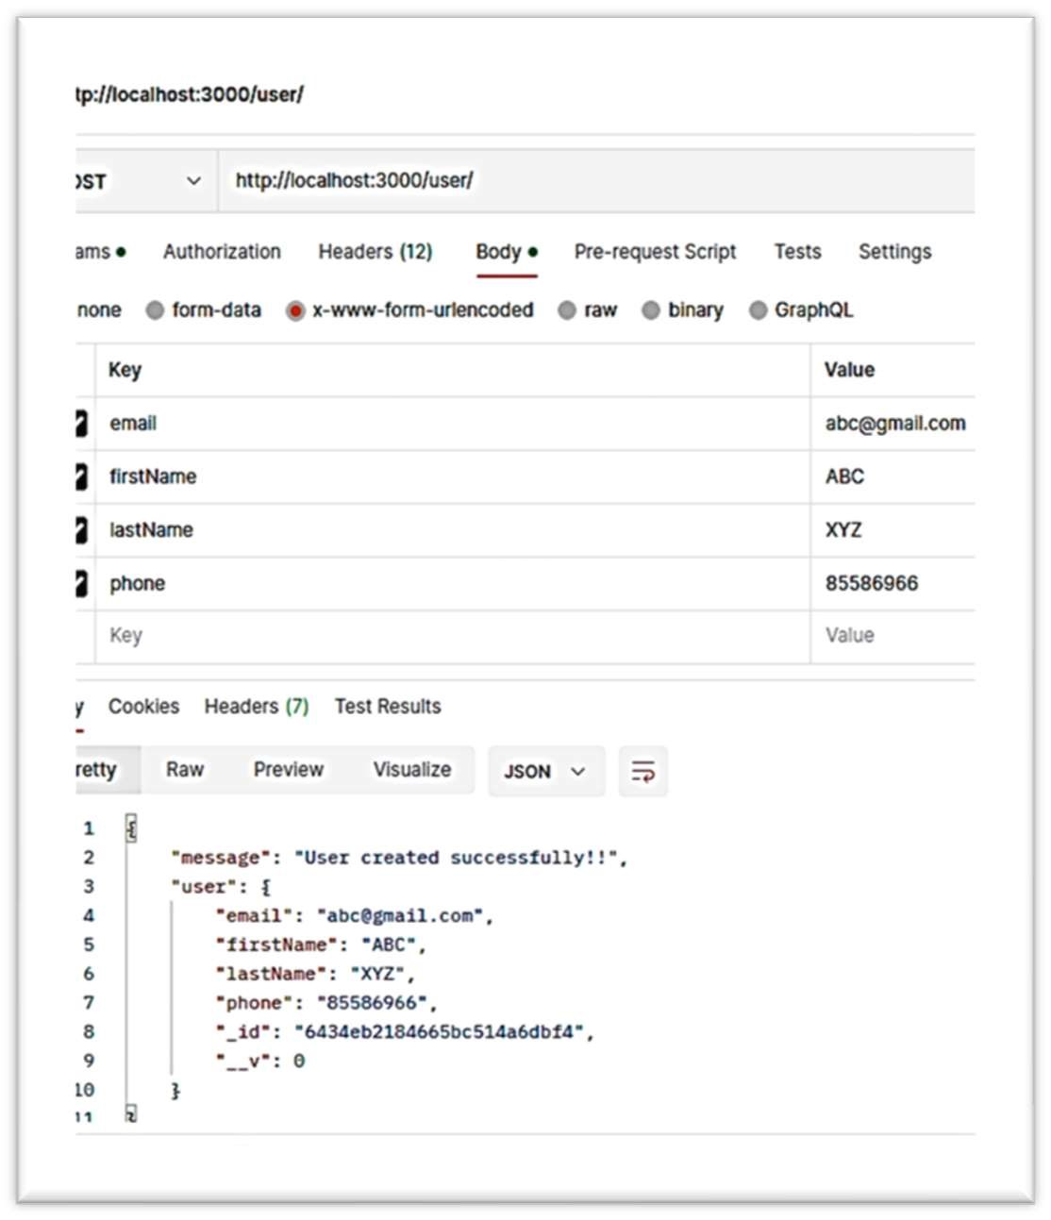

Display Single User:

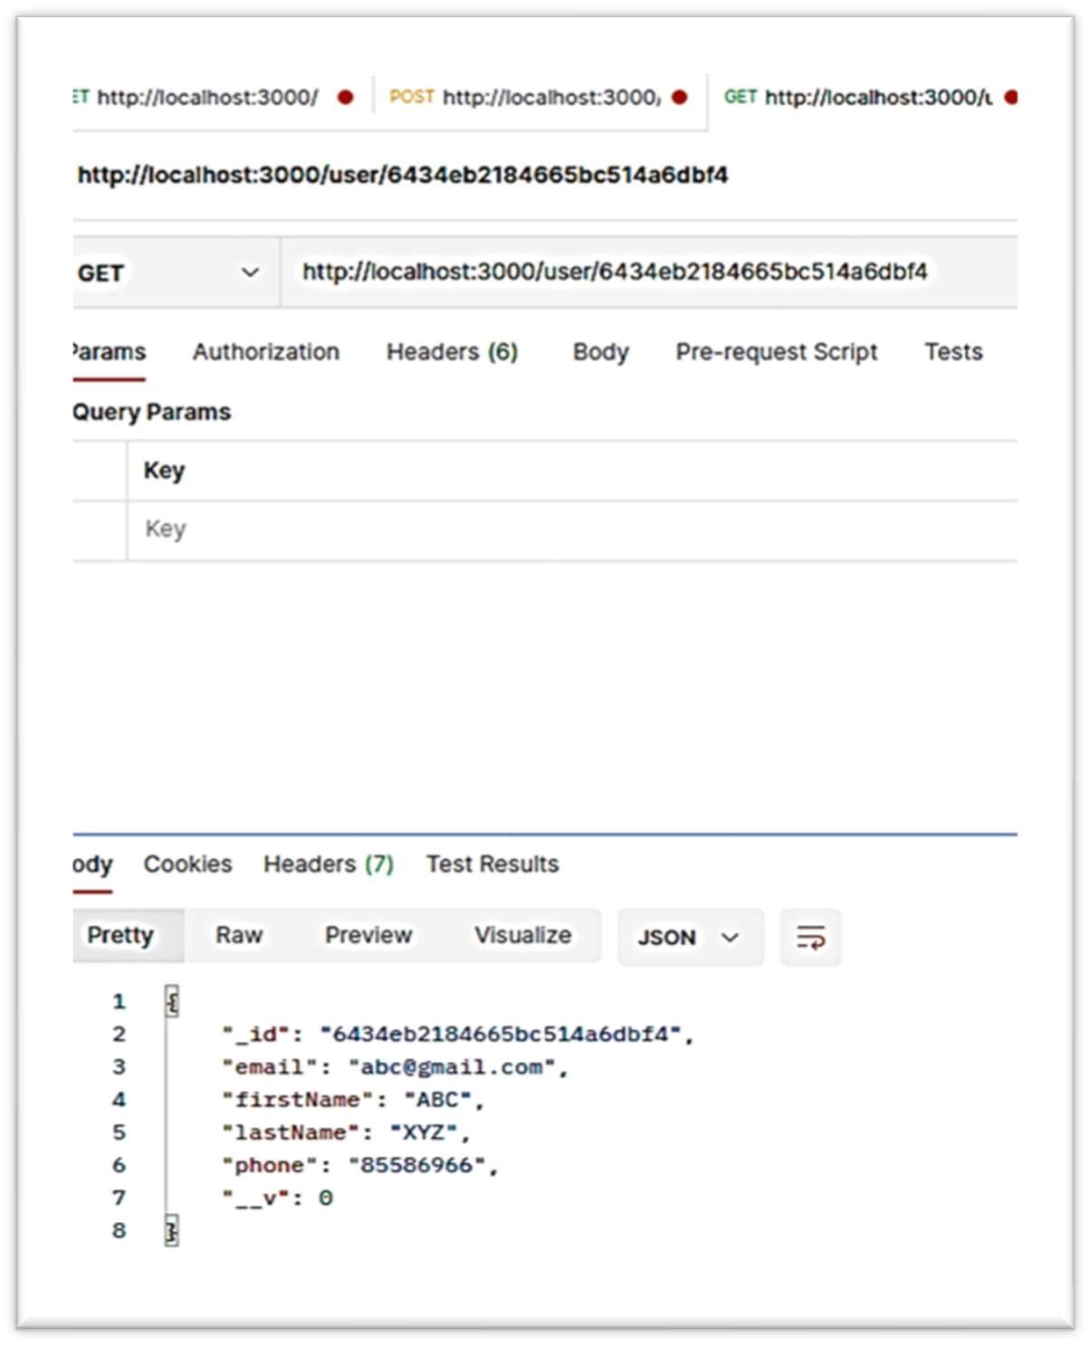

Update User:

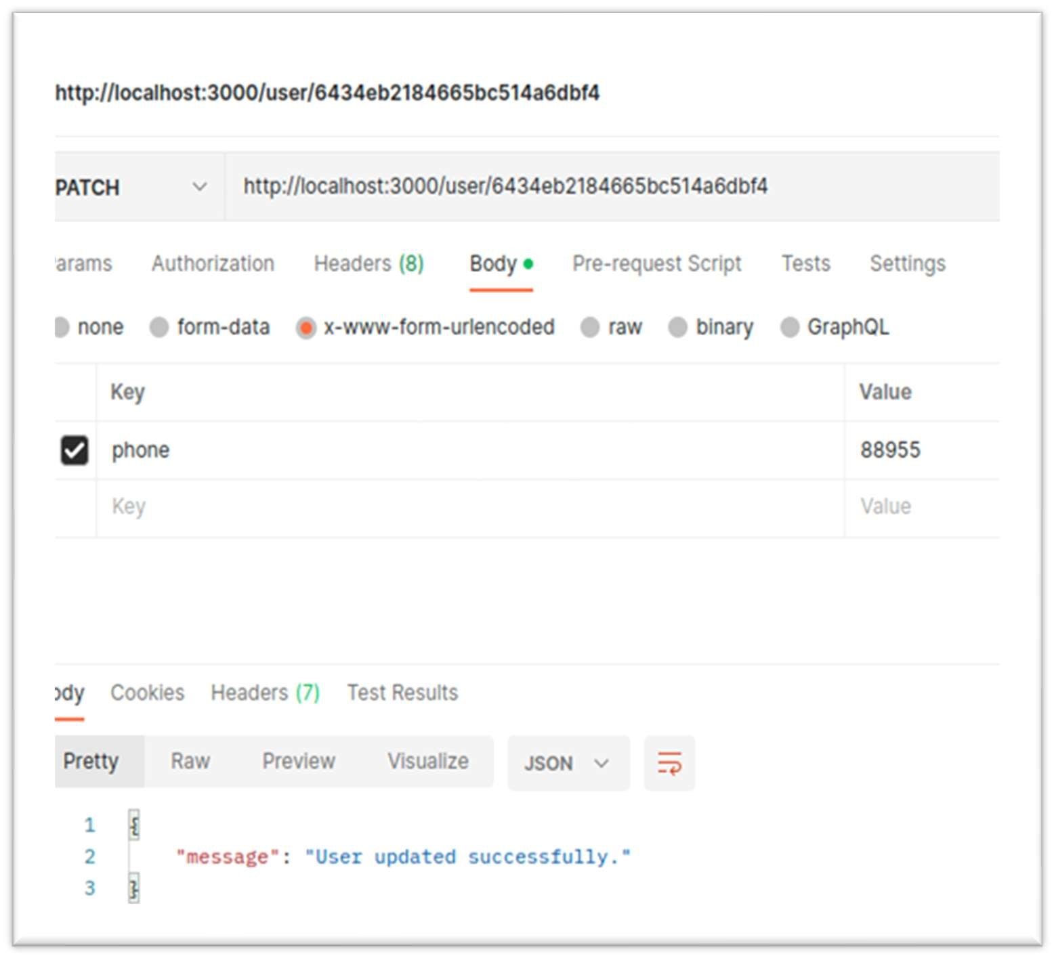

Delete User:

